**Online Feedback Form System**

**Abstract:** The present world is moving towards the development of online services. In this context, the educational domain can be contributed by developing an **online platform** that can be used for communication between administrator, faculties and students. Developing effective mechanisms for feedback collection in learning environments is particularly important at the frontiers of new knowledge. Valuing and asking for feedback has recognized benefits for both faculty and students. For Faculty to provide information for course design to further develop teaching skills as well as to provide better service to the students. For Students to feel valued and 'listened' to have ownership in their own learning to develop reflective thinking to be better informed in selecting a course/module. Faculties and Students can make a request, query or send an opinion to the administrator. Faculty-feedback system is intended to collect feedback about faculty from students. Any member of IIIT Allahabad can access the services provided by this online feedback form systemfrom any location via the Internet.

**Table of Contents**

**Table of Contents.............................................................................................................................................. i**

**Revision History............................................................................................................................................... ii**

**1. Introduction................................................................................................................................................ 1**

1.1 Purpose................................................................................................................................................................ 1

1.2 Intended Audience and Reading Suggestions..................................................................................................... 1

1.3 Product Scope...................................................................................................................................................... 1

**2. Overall Description.................................................................................................................................... 2**

2.1 System features................................................................................................................................................... 2

2.2 Operating Environment....................................................................................................................................... 3

2.3 Design and Implementation Constraints............................................................................................................. 3

2.4 Assumptions and Dependencies......................................................................................................................... 4

**3. External Interface Requirements............................................................................................................. 4**

3.1 User Interfaces.................................................................................................................................................... 4

3.2 Hardware Interfaces............................................................................................................................................ 4

3.3 Software Interfaces............................................................................................................................................. 4

3.4 Communications Interfaces................................................................................................................................ 5

**4. Other Nonfunctional Requirements........................................................................................................ 10**

5.1 Performance Requirements................................................................................................................................ 10

5.2 Safety Requirements.......................................................................................................................................... 10

5.3 Security Requirements....................................................................................................................................... 10

5.4 Software Quality Attributes............................................................................................................................... 10

**5.** **ER Diagram................................................................................................................................................... 10**

5.1 Conceptual ER Diagram.................................................................................................................................... 10

5.2 Physical ER Diagram........................................................................................................................................ 10

**1. Introduction**

**1.1 Purpose**

Students have a hard time getting in touch with the faculties and administrator of the institution. The only way is the mail which allows students, faculties and administrators to communicate with one another.

**From Student’s point of view**:

They need to ask queries to faculties related about the subject and administrators related to other matters like fee payment, course registration etc.

They need to give feedback and rating to the faculties.

**From the Faculty’s point of view:**

They need to query about teaching related matters to administration

Provide their opinion in any matter.

Also need to reply to the doubts and queries raised by the students.

This project is an attempt to get things done from the comfort of their homes in a much more convenient way. This software provides an online platform for all the above requirements like query and their reply, providing opinion, giving ratings anonymously to faculties etc.

**1.2 Intended Audience and Reading Suggestions**

This project is intended for the administration of an educational institution, here for only IIIT Allahabad managing their databases for faculties rating and replying to queries and looking to their opinions, faculties who want to clear doubts of students and query the administration about any matter from home in general, and any student of IIIT Allahabad seeking assistance in any subject directly from the faculty and administration.

**1.3 Project Scope**

The purpose of the online feedback form system is to ease query and feedback management and to create a convenient and easy-to-use application for students and faculties alike, trying to seek assistance. The system is based on a relational database. Above all, we hope to provide a comfortable user experience.

**2. Overall Description**

**2.1 System Features**

* Administrator Register/Login
* Faculty Register/Login
* Student Register/Login
* Send Query/Request/Opinion
* Reply to Query/Request/Opinion
* Give feedback to teachers
* View performance graphs
* Modify user credentials
* Filter through the discussions
* Account Reset/Logout/Delete

Students will have the following functionalities:

* Login
* Register
* Send Query/Request/Opinion to Admin
* Send Query/Request/Opinion to Faculty
* Give feedback to faculty based on the teaching experience. Students can give a value from 0 to 100 for lecture, demo, slides, lab, and interaction during the classes **anonymously**
* Modify credentials

Faculties will have the following functionalities:

* Login
* Send Query/Request/Opinion to Admin
* Reply to the Query/Request/Opinion from Student
* View a graph showing the average of all feedback given by all the students for each course taught by the faculty.
* Modify credentials
* Add or remove branches taught by the faculty

Admins will have the following functionalities:

* Login
* Reply to the Query/Request/Opinion from Student
* Reply to the Query/Request/Opinion from Faculty
* View a list of graphs containing performance of all the faculties for each course they are teaching

**2.2 Operating Environment**

* Operating System: Linux
* Frontend Platform: Flutter
* Database: PostgreSQL
* Deployment Service: Heroku

**2.3 Design and Implementation Constraints**

* Information regarding all conversations will be securely stored on the database accessible from the app.
* The Feedback management system is online 24 hours a day.
* PostgreSQL will be used as SQL engine and database.
* Heroku will be used to deploy database online to keep it centralized.

**2.4 Assumption and Dependencies**

The feedback management system platform depends on the credibility of the data fed to the databases by patients. Any form of text message sent by any user cannot be deleted or modified in order to keep the records authentic and trustworthy.

**3. External Interface Requirements**

**3.1 User Interfaces**

The interfaces type found on the website are as follows:

* UI of the homepage for Student
* UI of the homepage for Faculty
* UI of the homepage for Admin

Depending on the roles of the users, each user may see a different set of functionalities.

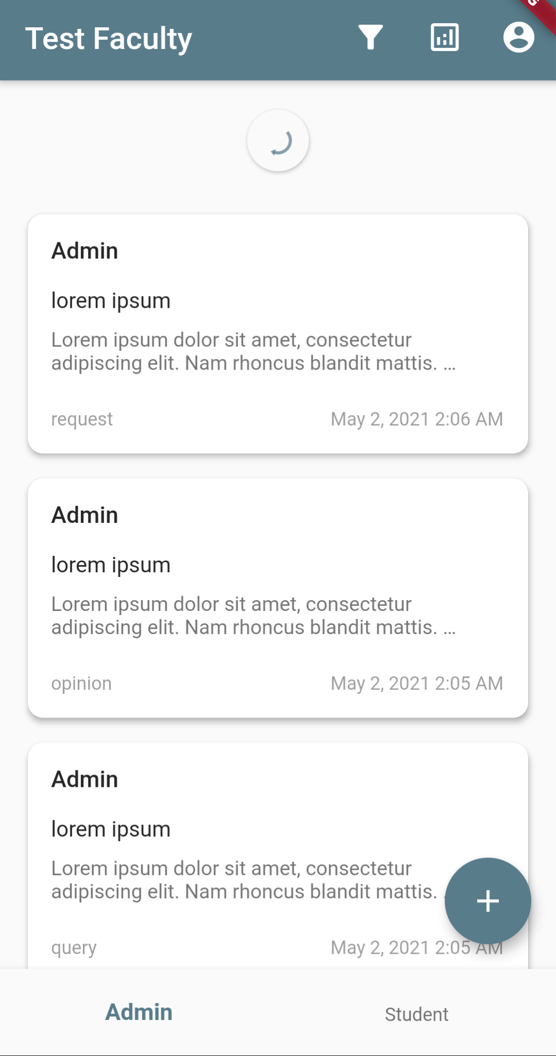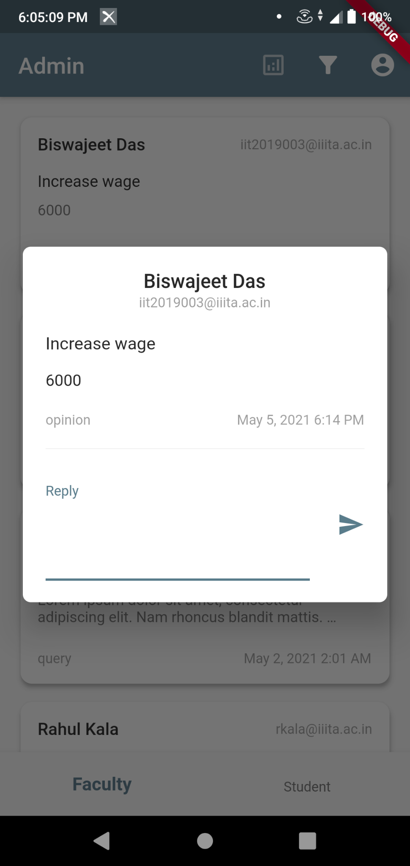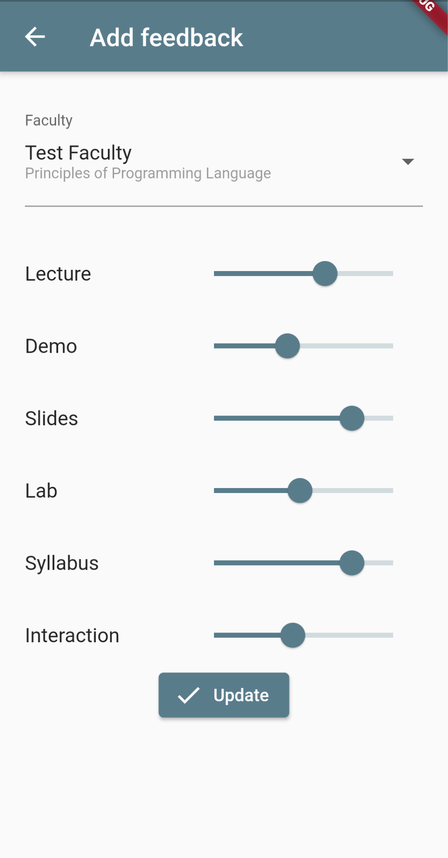

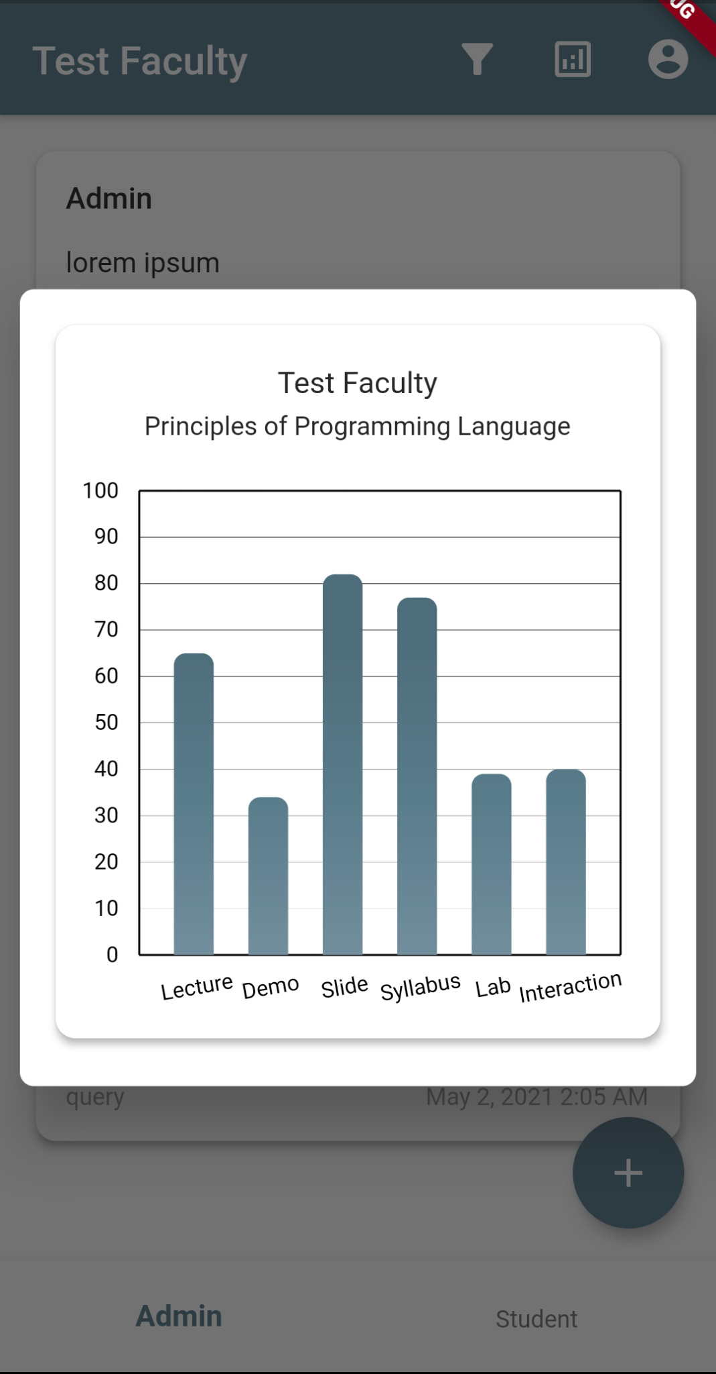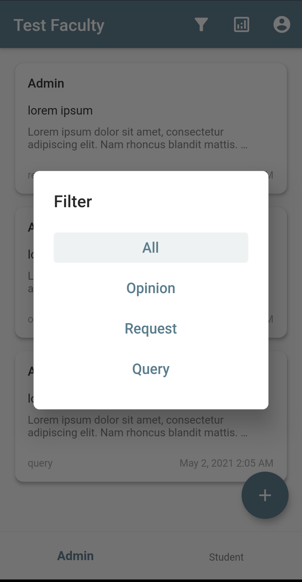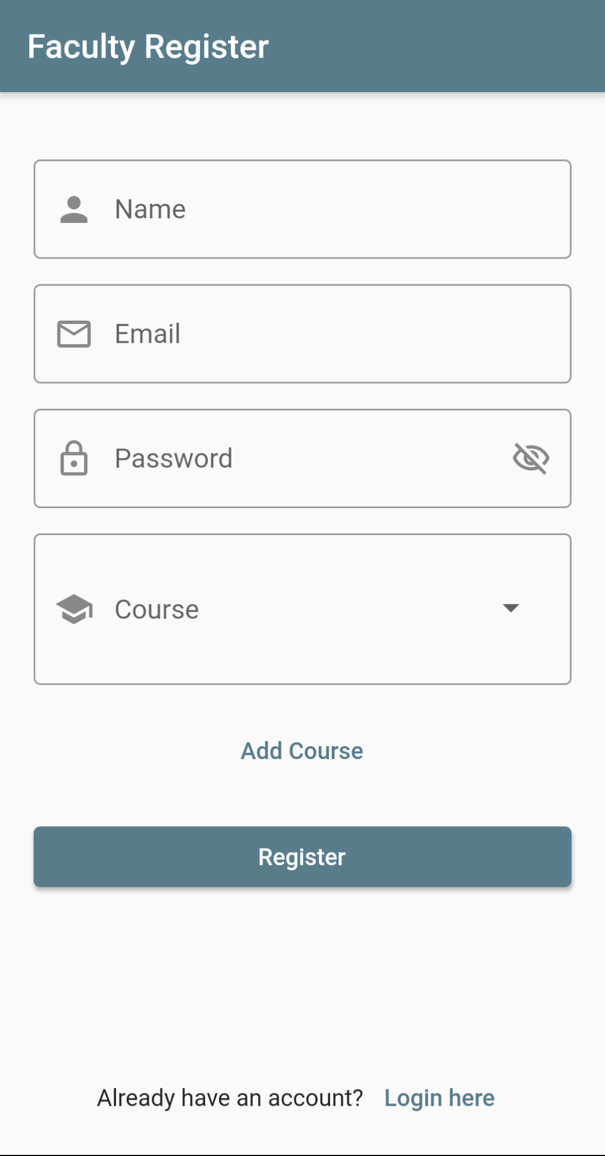

**3.2 Hardware Interfaces**

The app can be run on any mobile device running on Android.

**3.3 Software Interfaces**

The operating system must be Android with version 9 or above.

**3.4 Communications Interfaces**

The app purely online and needs active internet connection to fetch all the data therefore needs a data connection via cellular or the Wi-Fi.

**4. Other Nonfunctional Requirements**

**Performance Requirements :** The users shall be able to reach the app within 5 seconds. The navigation between pages shall take fewer than 1 second.

**Safety Requirements :** The application shall be able to do a validation check on the information provided in the user-authentication to avoid false or incomplete information and the ID being created is legit (and not fake).

**Security Requirements :** The system must automatically log out all users after closing the app. The system’s back-end servers shall only be accessible to an authenticated admin. Sensitive data will be encrypted before being sent over insecure connections like the internet.

**Software Quality Attributes :** The system provides storage of all data on the database on redundant computers with automatic switchover. The backup of the database is continuously maintained and updated to reflect the most recent changes.

**5. E-R Diagrams**

An Entity Relationship (ER) diagram is a type of flowchart that illustrates how “entities” such as people, objects or concepts relate to each other within a system. ER Diagrams are most often used to design or debug relational databases in the fields of software engineering, business information systems, education and research.

**5.1 Conceptual E-R Diagram**

Conceptual E-R Diagram is the highest-level view containing the least detail. Its value is showing the overall scope of the model and portraying the system architecture. It establishes a broad view of what should be included in the model set.

Following are the components of Conceptual E-R Diagram

**Entity** - Typically shown as a rectangle. Example - Branch, Faculty, Student, Course etc.

**Relationship** - Typically shown as diamonds or labels directly on the connecting lines. Example - faculty_course, branch_course, branch_sem, admin_faculty etc.

**Attributes -** Often shown as an oval or circle. Example - courseID, branchID, adminID, studentID, etc.

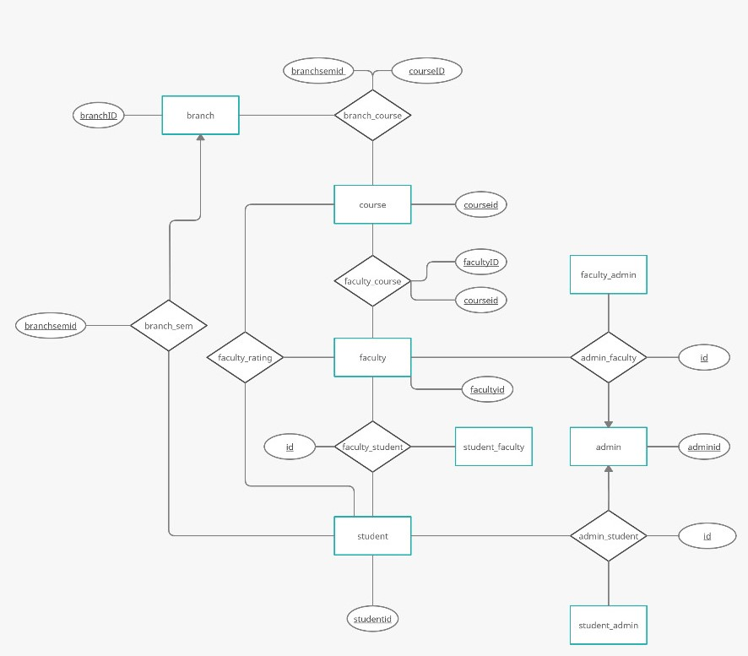

**5.2 Physical E-R Diagram**

The physical data model is the most granular level of entity-relationship diagrams, and represents the process of adding information to the database. Physical ER models show all table structures, including column name, column data type, column constraints, primary key, foreign key, and relationships between tables.

Each table is represented as follows.

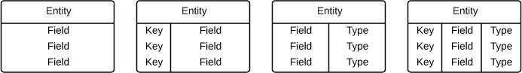

The bulb diagram represents primary keys, Purple - diamond keys are foreign keys and other blue - diamond shaped keys are normal keys.

Cardinality and ordinality are shown by the styling of a line and its endpoint, according to the chosen notation style.

